Press Release
  - World premiere: Automated blanket change
  - with RBC (Rapid Blanket Change)

Increase of efficiency and productivity
- Reduces blanket change times by more than the half
- Program controlled automated process by the press of a button

Stuttgart, 8.3.2018
It is the aim of every printing company to work as efficiently as possible and to increase the productivity of the printing presses. Downtimes must therefore be reduced as far as possible. The new RBC (Rapid Blanket Change) was developed on this basis. It reduces blanket change times by more than half. In addition, it also saves operating personnel, since only one operator is needed. The blanket change takes place automatically by program control at the press of a button.

Special requirements to be met by the blanket
The printing of metal sheets places extremely high demands on the printing press, in particular on those components that are in direct contact with the substrate. Here, the blanket is one of the components exposed to the most stress. With every print job, the sharp edges of the sheet cut into the blanket. The result is surface damage to the blanket in the format of the printed material. If a larger format is set up after a small format, this surface damage results in unwanted non-printing areas on the sheet. To solve this problem, care is taken as early as the job planning stage to ensure that the size of the formats is progressively reduced. In addition, the blankets are changed very frequently, typically once or even several times a day, depending on the frequency of the change of format and order structure of the customer.

Significant reduction in change times
The manual change of a blanket takes 6 - 8 minutes per printing unit. If all of the blankets of a 6-colour press are changed, this means a production downtime of at least 36 minutes, and 2 operators are tied down. With the RBC, the change time can be reduced to 2 minutes per unit and the change can easily be performed by one operator. This leads to a time saving of 65% and allows the second operator to devote himself to other tasks, for example preparing the print job at the ErgoTronic control console. If we take as an example a 6-colour MetalStar 3, in which the blankets are changed on a daily basis, this results in a reduction of downtimes from 180 minutes to 60 minutes per week.

Program and sensor-controlled process
The blanket change is program-controlled. The old blanket is automatically ejected, and the operator can effortlessly insert the new blanket with the help of the blanket change unit through a shaft in the tensioning rail. As soon as a sensor detects the correct position, all other operations are performed automatically. This high degree of automation increases process reliability significantly.

Reproducible results
A new blanket which MetalPrint supplies for UV and conventional inks was developed specially for the automated blanket change using the RBC system. During development, particular attention was paid to functionality with the RBC system, but the structure of the blanket was also adapted to the needs of metal decorating. Instead of the fabric carrier layer which is usually used on the market, the MetalPremium RBC blanket has a thermoplastic synthetic material as a carrier material; this rules out the possibility of the blanket stretching, thus rendering the regular, annoying retensioning of the blanket superfluous. No packing sheets are required either. Together with the sensor-controlled replacement of the blanket, many uncertainties can be avoided, such as uneven voltage or operating errors, and reproducibility is significantly increased.

Blankets to match the format
A special feature of the MetalPremium RBC blanket is that it can be stripped. The blanket can be stripped to match the format of the substrate. This prevents unwanted ink transfer from the printing plate via the blanket to the impression cylinder outside the print format, so-called "picture framing", and the cleaning intervals of the ink transfer can be prolonged. "Picture framing" occurs particularly often in UV printing presses and requires significantly more cleaning work, particularly if a UV intermediate dryer is used, because then the ink dries on the impression cylinder. This advantage of the blanket is particularly appreciated by MetalPrint customers when printing opaque white. Depending on the format of the substrate, blankets can be cut to size and reused.
The customer gains valuable production time and at the same time avoids costly and time-consuming cleaning work on the printing press.

Photos:

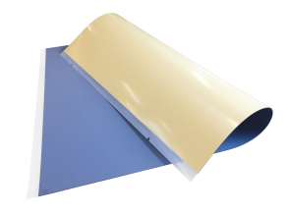
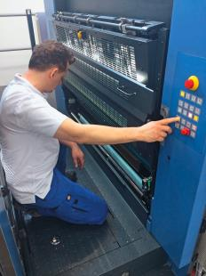

Fig. 2

Fig. 1

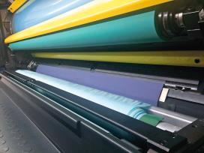

Fig. 3

Captions
Fig. 1: The automated blanket change takes place at the press of a button, only one operator is
needed.
Fig. 2: MetalPremium RBC – the blanket specially developed for the RBC
Fig. 3: The innovative blanket has a thermoplastic synthetic layer as a carrier material

Press contact
KBA-MetalPrint GmbH
Ursula Bauer
T +49 711 69971-859
M ursula.bauer@kba-metalprint.de

