Press release

Digital printing - a future trend in the metal packaging industry
Koenig & Bauer MetalPrint at the thyssenKrupp Rasselstein Future Symposium
- Discussion platform for future trends
- CS MetalCan with new groundbreaking technology
- Digital printing as a flexible alternative for short runs
Stuttgart, July 23rd
In May this year Koenig & Bauer MetalPrint presented itself as a partner for metal decorating at the Future Symposium of thyssenkrupp Rasselstein in Andernach. The event, which takes place every 3 years, sees itself as a discussion platform for new trends in the steel packaging industry. This is where innovations are presented and experts emerge.
In addition to MetalStar 3, which with its many automation features sets standards for top performance and short make-ready times, Koenig & Bauer MetalPrint is now launching the new CS Metal-Can, a highly efficient machine for the decoration of two-piece beverage cans. Thanks to a new groundbreaking and extremely economical keyless inking unit technology with direct drive, this "decorator" is stable in the target color within a very short time and therefore consumes considerably less waste than previous competitor products.
Shortest runs, printing without printing plates, personalisation - digital printing is the trend of the future! With the MetalDecoJET, Koenig & Bauer MetalPrint has developed the first digital printing press specifically for the metal packaging industry. With this new technology, an absolutely uniform ink application and outstanding print quality can be achieved. The water-based inks are food safe, a very important argument for the food industry.
There is still a certain reluctance to use digital printing on the metal packaging market. To convince the Future Symposium guests of the outstanding properties of digital printing, thyssenkrupp Rasselstein together with Koenig & Bauer MetalPrint and Pirlo came up with something special. Each visitor received a can digitally printed on the MetalDecoJET and processed by Pirlo as a gift. The visitor feedback on the digitally printed cans was positive throughout. The print quality was so convincing that many of the visitors confused digital printing with offset printing.
At the Koenig & Bauer MetalPrint stand, interested visitors were able to see for themselves the outstanding print quality of the MetalDecoJET. There was a selection of cans with various design motifs filled with sweets. If you are interested in digital printing, we would be happy to send you a sample can.
.

Photos:
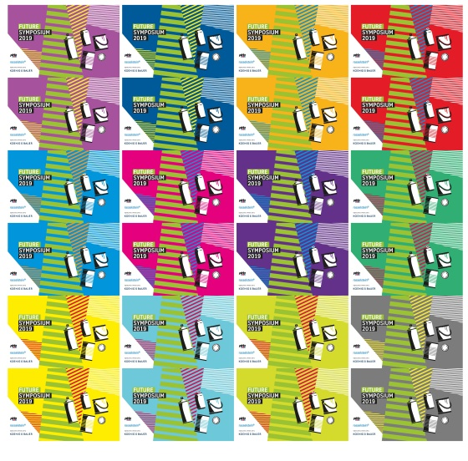
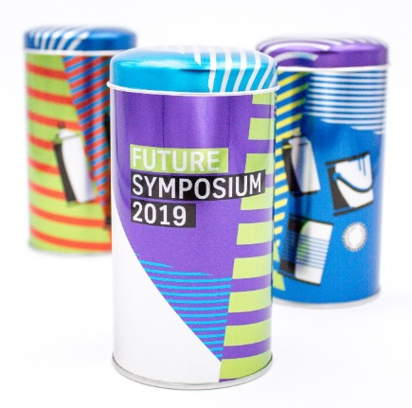

The can designed especially for the Future Symposium was produced in a number of colour variants
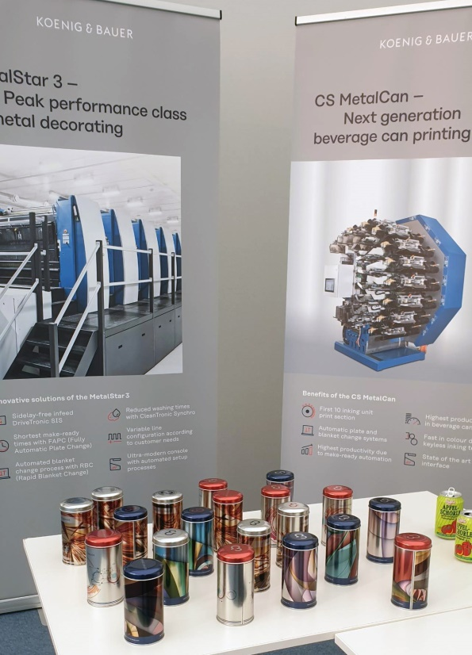
At the Koenig & Bauer MetalPrint stand, interested visitors were able to see for themselves the outstanding print quality of the MetalDecoJET.

Contact person for the press
Koenig & Bauer MetalPrint GmbH
Ursula Bauer
Marketing & Corporate Communications
T +49 711 69971-859
M ursula.bauer@kba-metalprint.de

About Koenig & Bauer
Koenig & Bauer is the oldest printing press manufacturer in the world with the broadest product range in the industry. For more than 200 years, the company has been supporting printers with innovative technology, tailor-made processes and a wide array of services. The portfolio ranges from banknotes, via board, film, metal and glass packaging, through to book, display, coding, magazine, advertising and newspaper printing. Sheetfed and webfed offset and flexo printing, waterless offset, intaglio, simultaneous perfecting and screen printing or digital inkjet – Koenig & Bauer is at home in virtually all printing processes and is the market leader in many of them. In the financial year 2018, the approximately 5,700 highly qualified employees worldwide generated annual sales of more than EUR 1.2 billion.
Further information can be found at: www.metalprint.koenig-bauer.com
www.koenig-bauer.com

